**MilDaq - Signal Analysis system**

*MilDaq signal analyzer system provides reliable and precise measurements for vibration monitoring and analysis applications. MilDaq is a portable USB 2.0 full speed voltage input data acquisition module (fully compatible with both USB 1.1 and USB 2.0 ports) that can be used with either desktop or laptop PCs.*

*These rugged, compact modules are powered directly using DC Adapter power making them ideal for Industrial as well as portable Laboratory uses with different input voltage standards.*

**Features**



*Vibration Analysis system for Acceleration Sensing*

*Static and Dynamic acceleration measurement capability*

*Velocity and Displacement processing*

*Sensor interface through 6 pin Industrial MIC type connector*

*USB 2.0 interface for communication*

*Signal Analysis and data display application*

*Data Archival - Raw data as well as processed data in excel format*

*Real Time data display in time and Frequency Domain*

*User friendly GUI for control and configuration of the system parameters*

*Intuitive operation shortens the learning curve for faster implementation*

*Simultaneous display for vibration parameters for ease of analysis and modeling*

*16/12/8/4 Channel - Data Acquisition system provides connectivity up to five Triaxial accelerometer measurements*

*Embedded intelligence using hardcore DSP engine for high performance applications*

*Compact, rugged design holds up to any plant environment, unique solution using integrated module approach*

*Excellent protection for input supply upto 32 V and high immunity to external noise*

*Expansion connectors for mixed signal and Digital I/O functionality*

**Specifications**

|  |  |
| --- | --- |
| **Parameter** | **Value** |
| *Peak Acceleration* | *+/- 3 g* |
| *Sampling Frequency* | *1 KHz (Options available upto 100KHz)* |
| *Analog Bandwidth* | *DC-100 Hz (limited for low frequency applications)* |
| *Input Coupling* | *DC* |
| *Max Analog input voltage* | *3.3V* |
| *ADC Dynamic range in bits* | *24 bits* |
| *SP Gain* | *42 dB* |
| *Frequency Resolution* | *0.05Hz (FFT)* |
| *Digital Architecture* | *32 bit, DSP Engine MAC based* |
| *Antialiasing Filter type* | *3rd order Butterworth Passive LC* |
| *External Digital I/O* | *8-16 Nos (optional PWM output)* |
| *Supply standard* | *8-12V DC input* |
| *Operating Temperature* | *‘-10 to 50 deg C* |
| *Communication* | *USB 2.0* |
| *Reference Clock* | *Internal/ option for external phase locking* |

**Block Level Schematic**

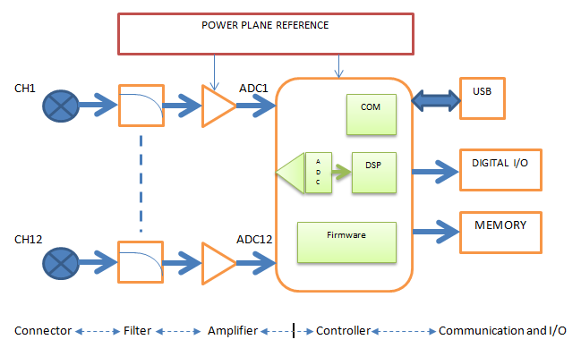

**System Setup and Architecture**

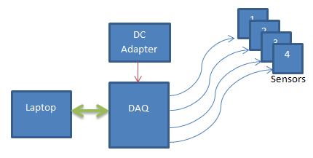

**Components of the system**

1. Laptop with the Kampana installed in it based on the users choice of OS for operation.

* Labview based software
* C++/Java based Application (development on request)

1. Data Acquisition unit

* 16/12/8/4 channel options
* Direct AC input power options for benchtop applications
* Lemo type Connector option if required (need to mention the detail in the Order copy).

1. Linear power supply Adapter
2. Sensors

* Single Axis, Dual Axis, and Triaxial
* Acceleration Range options such as 3g, 10g and 100g approx. (sensitivity will change based on the range selected.

Note: Customization of the software and hardware to whatever possible extent will be done based on the user’s requests and the feasibility.

We will develop custom products for customer whose requirements are not suffixed using the existing product. Please get in touch with Senpronics for the same.

**Kampana**

*Kampana – This application acts as the User interface to the Data Acquisition hardware; it uses USB as the communication medium. All the control, processing and archival is done using this application; we can verify all the features of the system such as Acquisition, offline data display, Archival etc.*

**The GUI application lets you interact and control the system in a very friendly manner and perform the following functions:**

*Configure all input channel settings for the attached sensors.*

*Load/save multiple hardware configurations.*

*Display acquired data during acquisition as absolute values and time domain waveforms*

*Time/Trigger/Even based data acquisition option.*

*User programmable Digital Filter settings.*

*Offline data plotting and analysis.*

*Perform FFT (Fast Fourier Transforms) operations on the acquired analog input data.*

*Open recorded data and view in tabular format for further analysis.*

*External clock reference option for precise timings and phase locking with other systems.*

*Selection for plotting data in time or frequency domain.*

*Real time parameter values displays for Acceleration, Velocity and Displacement along with time domain plots for the same.*

*Spectral Plot of up to 500Hz frequency range with an excellent resolution as of 0.05Hz.*

*Displacement Vs frequency display plot for structural analysis.*

*Different file generation for continuous and finite time based data acquisition.*

*Channel selection for user, allowing viewing of individual plots for better visibility.*

*Data backup with time stamping for Archival.***Dimensions**

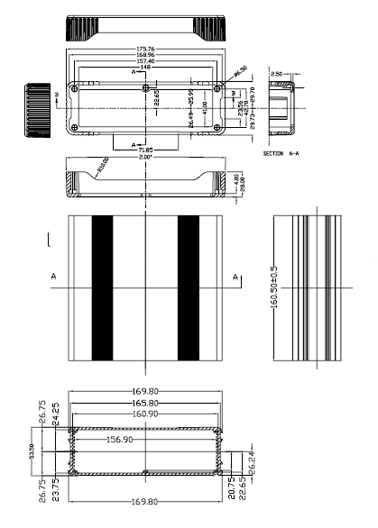

**Applications**

Our data acquisition products are used in maintenance, prototype validation, Research studies and mechanical design as well as field applications. Some prominent examples are:-

**Analysis of Civil structures:** Good analysis starts with good data. For that reason, all the tools for efficient andaccurate acquisition have been integrated into our structural analysis solutions.

**Research and Development:** A very efficient tool for vibration analysis studies and modeling. It could also becustomized for use in acoustics, temperature and several other data acquisition and processing applications.

**Industrial Application:** Implementation of Machine Health Monitoring and early warning mechanisms has beena very rewarding application of our data acquisition products.

**Software Options**

Many software choices are available for application development, from ready-to-measure applications to programming environments, and run under Microsoft® Windows® XP/Vista/7/8.

Option to customize for Linux platform on customers demand.

**User Manual**

The MilDaq Series data acquisition units include a user’s manual that provides information on getting started on the system for use. The manual is provided in electronic (PDF) format on the Data Acquisition software CD provided with the module.

**Technical Support**

Application engineers are available by phone and email during normal business hours to discuss your application requirements.

**Data Analysis Packages**

The following software is available for purchase separately:

-Modal Analysis

-Machine Health Monitoring

**Ordering Summary**

All Data Acquisition hardware products are covered by a 1-year warranty and more importantly further support to the customer till the product lifetime validity. For pricing information, please contact your local sales division.

**Contact Address**

SENPRONICS

Site No 33, 8th Cross,

1st stage, Ashraya Layout,

Mahadevpura,

Bangalore – 560048

*Email: -* [*info@senpronics.com*](mailto:info@senpronics.com)

[*www.senpronics.com*](http://www.senpronics.com)